Report : Allsec Technologies Attrition Rate.

Content:
1. Data pre-processing and EDA.
  - Data Loading
  - Load Libraries
  - Summary and dimensionality checking of the data.
  - Missing value Treatment.
  - Martial status
  - Working with date and finding out Age.
  - Managing address field
  - Managing Highest educational qualification
  - Managing Overall experience
  - Managing Length of Service
  - Managing Job Title
  - Defining Target variable
  - Feature Engineering (If any).
2. Visualization.
3. Model.
4. Continual Service Improvement plan, prescriptive Analytics.

Data Processing
1.1 Data Loading

Below is the employee master data set you’ve loaded in R console and that’s showing 10095 data points each having 16 attributes. So dimensionality of the data is (10095*16).

Data Cleaning and assumption:
Data information across 3 Databases.doc

Code:
Attrition Rate.R

Visualization & Findings (Descriptive Statistics)

> table(Test_Final_1$Gender,Test_Final_1$Marital.Status)

Married Single
F 668 2929
M 599 5326

> table(Test_Final_1$Highest.Educational.Qualification,Test_Final_1$Marital.Status)

Married Single
10th 5 78
Diploma 22 274
Graduation 643 4524
HSC 296 2105
Post Graduate Diploma 8 10
Post Graduation 235 438
Professional 17 15
PUC 41 811

> table(Test_Final_1$Resigned,Test_Final_1$Region_1)

Bangalore Chennai Dallas Hyderabad Manila Mumbai New Delhi Pune Trichy
0 570 3013 0 16 0 204 3546 27 101
1 299 795 0 4 0 117 811 3 16

> table(Test_Final_1$Overall.Experience,Test_Final_1$Resigned.y)

0 1
1Year 298 80
2Year 4674 1424
3Year 61 49

> table(Test_Final_1$Length.of.Service,Test_Final_1$Resigned.y)

0 1
0 0 0
1 1892 1008
10 4 23
11 11 36
12 10 31
13 7 19
14 3 23
15 0 11
16 2 10
17 3 8
18 0 4
2 2548 354
3 2126 177
4 570 101
5 150 61
6 49 42
7 63 73
8 32 38
9 7 26

** Important finding: 1,2 Length

> table(Test_Final_1$Resigned.y,Test_Final_1$Region_1)

Bangalore Chennai Dallas Hyderabad Manila Mumbai New Delhi Pune Trichy
A 299 795 0 4 0 117 811 3 16
I 570 3013 0 16 0 204 3546 27 101

> table(Test_Final_1$Resigned.y,Test_Final_1$Sal_bin)

0 1 2 3 4 5 6
A 131 232 147 129 118 110 1178
I 2240 1766 1014 712 523 381 841

> table(Test_Final_1$Resigned.y,Test_Final_1$Gender)

F M
A 724 1321
I 2873 4604

> table(Test_Final_1$Resigned.y,Test_Final_1$Marital.Status)

Married Single
A 396 1649
I 871 6606

Density Curve visualization:

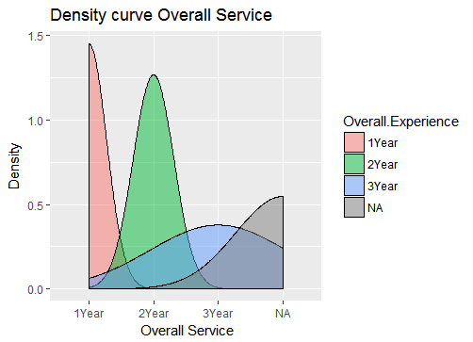

Age Vs Salary
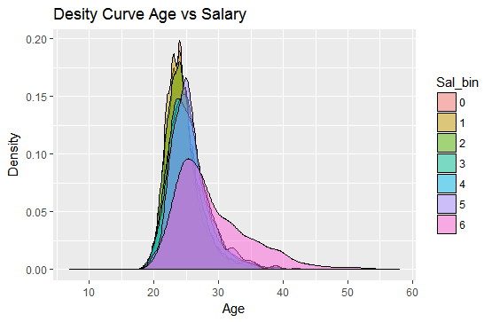
Age Vs Marital Status.
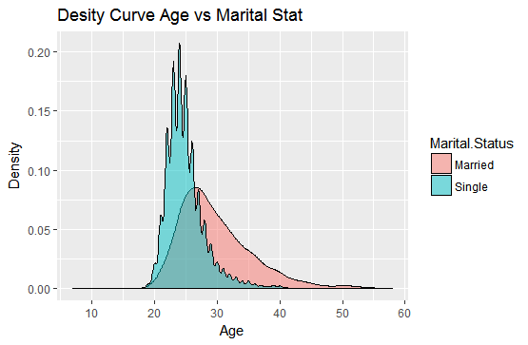

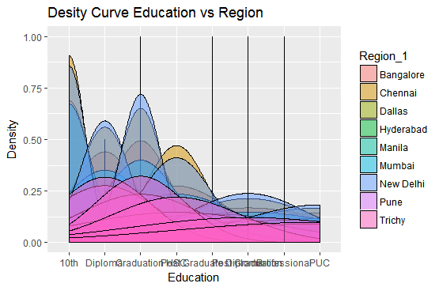

Boxplot with 3 Variables:

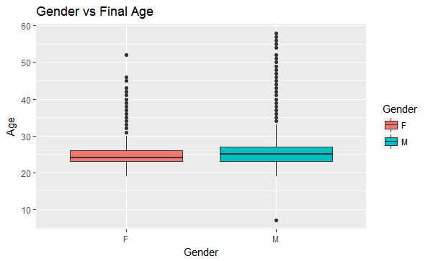

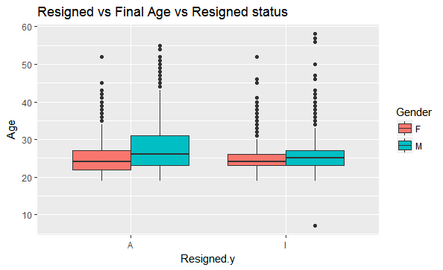

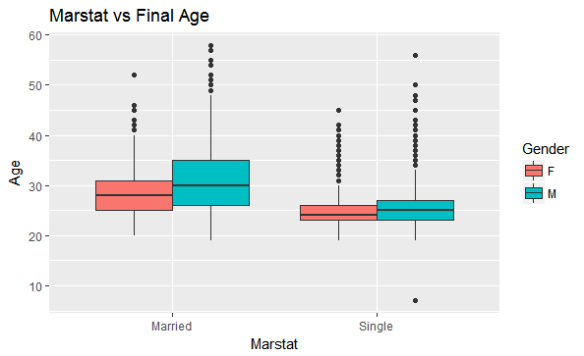

Region vs Gross pay Distribution

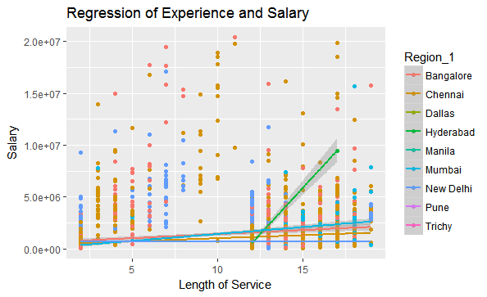

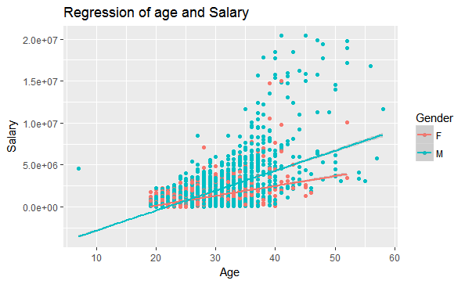

Final Age Distribution:
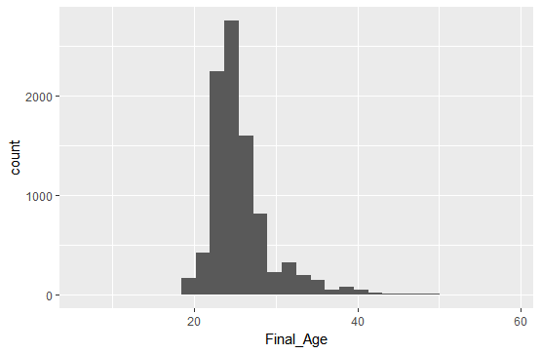

Histogram of Gross Pay
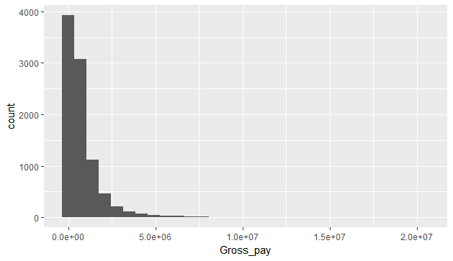

Scatterplot:

Final age vs gross pay distribution
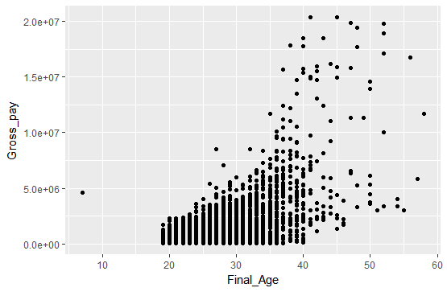

Length of Service vs Gross Pay distribution
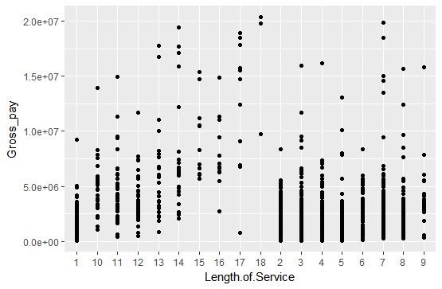

Boxplot: (2 Variable

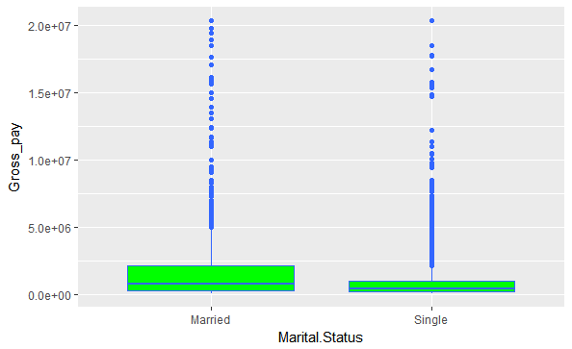

Salary Bin Vs Gender
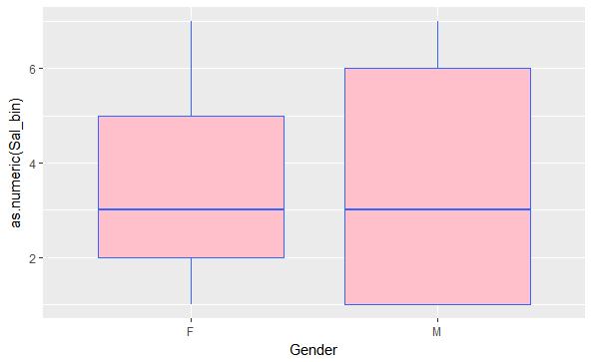

Age Distribution region wise
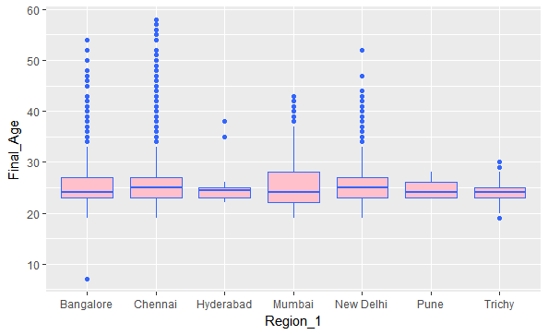

Region wise Salary distribution

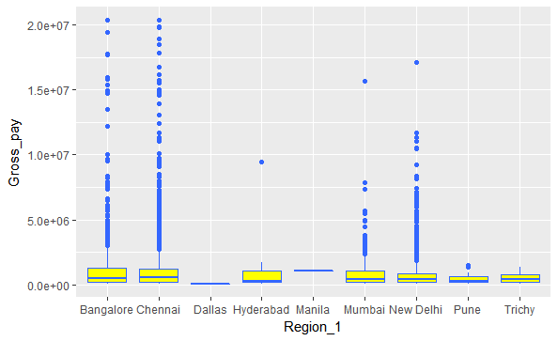

Modification (Limiting Salary value)

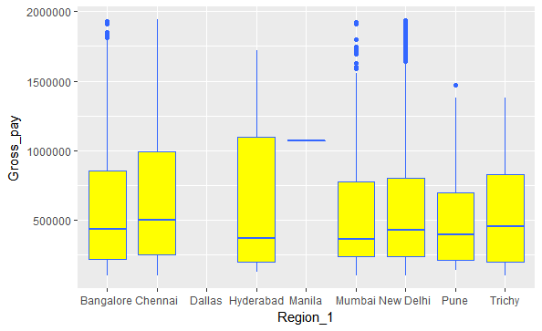

Violin Chart
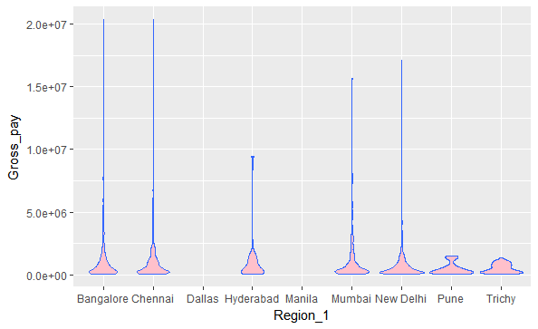

Modified Violin chart

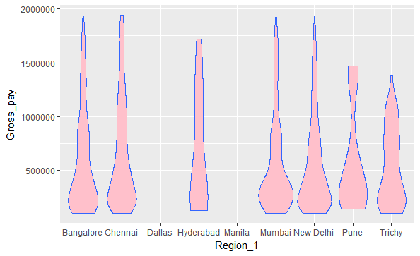

Some More Visualization

1. Dept wise Goss Salary distribution

Dept and Vs pie.html

2. Education wise Gross Salary distribution

Education vs Gross sal pie.html

3. Gender wise Gross salary distribution (Boxplot)

Gender vs Gross pay1.html

4. Overall Experience and Gross Salary distribution

Gross pay vs Overall.Experience

5. Marital Status vs Gross Salary distribution

Marstat vs Gross pay.html

6.

Tree Model: Visualization

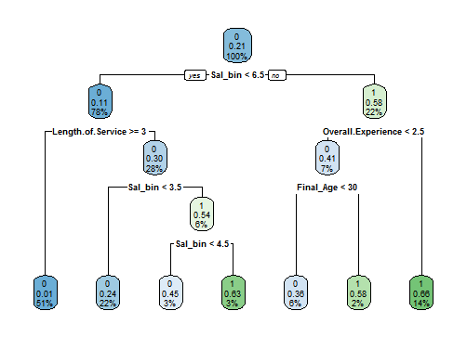

FancyRpartPlot:

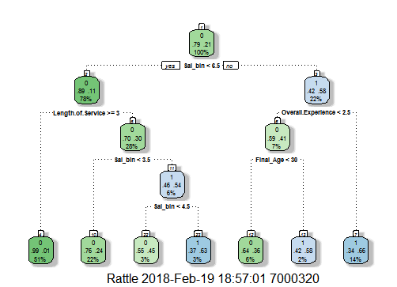

Neural Netwrok Model:

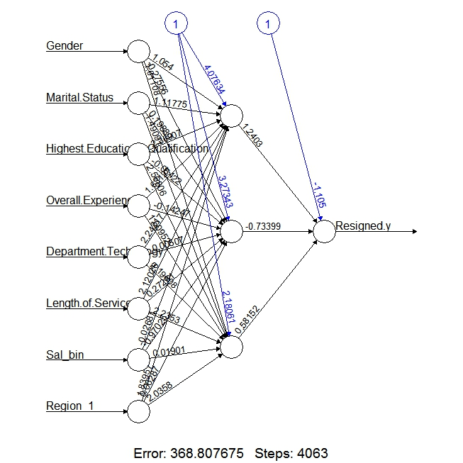

AUC Curve:

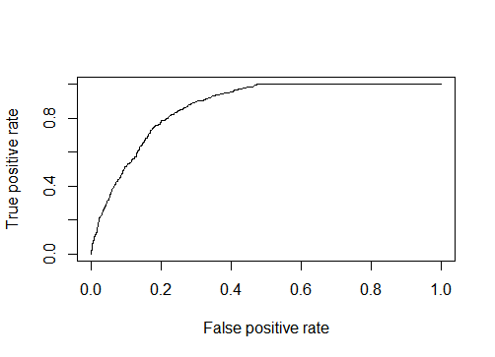

Random Forest

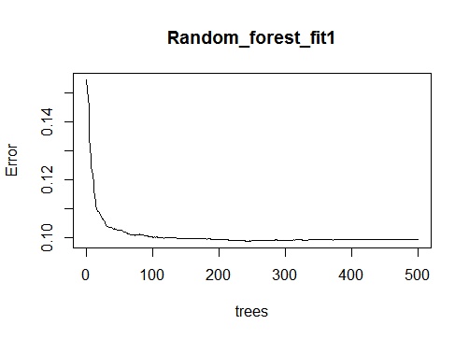
Tree based Model Result
> confusionMatrix(test1_nn$Resigned.y,prediction1)
Confusion Matrix and Statistics

Reference
Prediction 0 1
0 2015 188
1 279 375

Accuracy : 0.8365
95% CI : (0.8225, 0.8499)
No Information Rate : 0.8029
P-Value [Acc > NIR] : 2.205e-06

Kappa : 0.5132
Mcnemar's Test P-Value : 3.118e-05

Sensitivity : 0.8784
Specificity : 0.6661
Pos Pred Value : 0.9147
Neg Pred Value : 0.5734
Prevalence : 0.8029
Detection Rate : 0.7053
Detection Prevalence : 0.7711
Balanced Accuracy : 0.7722

'Positive' Class : 0

Modified Tree:

> confusionMatrix(test1_nn$Resigned.y,prediction_modified)
Confusion Matrix and Statistics

Reference
Prediction 0 1
0 2027 176
1 246 408

Accuracy : 0.8523
95% CI : (0.8387, 0.8651)
No Information Rate : 0.7956
P-Value [Acc > NIR] : 3.5e-15

Kappa : 0.5652
Mcnemar's Test P-Value : 0.0007826

Sensitivity : 0.8918
Specificity : 0.6986
Pos Pred Value : 0.9201
Neg Pred Value : 0.6239
Prevalence : 0.7956
Detection Rate : 0.7095
Detection Prevalence : 0.7711
Balanced Accuracy : 0.7952

'Positive' Class : 0

Regression Model:
1St Iteration: (Full model)

Call:
glm(formula = Resigned.y ~ ., family = binomial(link = "logit"),
data = train_nn, control = list(maxit = 50))

Deviance Residuals:
Min 1Q Median 3Q Max
-2.70271718 -0.55025812 -0.21687409 -0.09463829 2.34219566

Coefficients:
Estimate Std. Error z value Pr(>|z|)
(Intercept) -3.834811821 0.452538533 -8.47400 < 0.000000000000000222 ***
Gender 0.185362421 0.080088864 2.31446 0.02064254 *
Marital.Status 0.016885714 0.116569986 0.14485 0.88482557
Highest.Educational.Qualification 0.070290734 0.025291743 2.77920 0.00544935 **
Overall.Experience 0.092974297 0.011207964 8.29538 < 0.000000000000000222 ***
Department.Technology -0.010169090 0.003531915 -2.87920 0.00398685 **
Length.of.Service -0.221930007 0.009725870 -22.81852 < 0.000000000000000222 ***
Job.title 0.025786262 0.002255520 11.43251 < 0.000000000000000222 ***
Supporting.market 0.005399809 0.001570835 3.43754 0.00058702 ***
Final_Age -0.004705246 0.010597303 -0.44400 0.65703964
Sal_bin 0.692932970 0.023757398 29.16704 < 0.000000000000000222 ***
Region_1 -0.064782231 0.014816641 -4.37226 0.000012297 ***
---
Signif. codes: 0 ‘***’ 0.001 ‘**’ 0.01 ‘*’ 0.05 ‘.’ 0.1 ‘ ’ 1

(Dispersion parameter for binomial family taken to be 1)

Null deviance: 6828.0534 on 6664 degrees of freedom
Residual deviance: 4437.4434 on 6653 degrees of freedom
AIC: 4461.4434

Number of Fisher Scoring iterations: 6

Important variables are Gender, Highest Educational Qualification, Overall Experience, Dept, Length of service, Job title, , supporting market, Sal bin and Region. Next iteration we are choosing the variables that are important only.

2nd Iteration:

> summary(Regression_fit_1)

Call:
glm(formula = Resigned.y ~ Overall.Experience + Length.of.Service +
Job.title + Sal_bin + Region_1, family = binomial(link = "logit"),
data = train_nn)

Deviance Residuals:
Min 1Q Median 3Q Max
-2.68586157 -0.55236568 -0.22921162 -0.09939932 2.20617495

Coefficients:
Estimate Std. Error z value Pr(>|z|)
(Intercept) -3.295288254 0.164300047 -20.05653 < 0.000000000000000222 ***
Overall.Experience 0.095004291 0.011057142 8.59212 < 0.000000000000000222 ***
Length.of.Service -0.221957470 0.009603360 -23.11248 < 0.000000000000000222 ***
Job.title 0.024492005 0.002103927 11.64109 < 0.000000000000000222 ***
Sal_bin 0.689594884 0.023076028 29.88360 < 0.000000000000000222 ***
Region_1 -0.066094020 0.014770102 -4.47485 0.0000076464 ***
---
Signif. codes: 0 ‘***’ 0.001 ‘**’ 0.01 ‘*’ 0.05 ‘.’ 0.1 ‘ ’ 1

(Dispersion parameter for binomial family taken to be 1)

Null deviance: 6828.0534 on 6664 degrees of freedom
Residual deviance: 4461.2863 on 6659 degrees of freedom
AIC: 4473.2863

Number of Fisher Scoring iterations: 6

ANOVA Test.

> anova(Regression_fit_1, test = "Chisq")
Analysis of Deviance Table

Model: binomial, link: logit

Response: Resigned.y

Terms added sequentially (first to last)

Df Deviance Resid. Df Resid. Dev Pr(>Chi)
NULL 6664 6828.0534
Overall.Experience 1 291.44902 6663 6536.6044 < 0.000000000000000222 ***
Length.of.Service 1 140.84385 6662 6395.7606 < 0.000000000000000222 ***
Job.title 1 575.02627 6661 5820.7343 < 0.000000000000000222 ***
Sal_bin 1 1339.26319 6660 4481.4711 < 0.000000000000000222 ***
Region_1 1 20.18481 6659 4461.2863 0.0000070309 ***
---
Signif. codes: 0 ‘***’ 0.001 ‘**’ 0.01 ‘*’ 0.05 ‘.’ 0.1 ‘ ’ 1

Regression Accuracy:

> confusionMatrix(test1_nn$Resigned.y,Reg_predict)
Confusion Matrix and Statistics

Reference
Prediction 0 1
0 2088 115
1 385 269

Accuracy : 0.8249912
95% CI : (0.8105524, 0.8387611)
No Information Rate : 0.8655933
P-Value [Acc > NIR] : 1

Kappa : 0.4200855
Mcnemar's Test P-Value : <0.0000000000000002

Sensitivity : 0.8443186
Specificity : 0.7005208
Pos Pred Value : 0.9477985
Neg Pred Value : 0.4113150
Prevalence : 0.8655933
Detection Rate : 0.7308365
Detection Prevalence : 0.7710886
Balanced Accuracy : 0.7724197

'Positive' Class : 0

3. Neural Network.

Confusion Matrix and Statistics

Reference
Prediction 0 1
0 2023 337
1 208 289

Accuracy : 0.8092405
95% CI : (0.7943445, 0.8235001)
No Information Rate : 0.780889
P-Value [Acc > NIR] : 0.0001092934

Kappa : 0.3979256
Mcnemar's Test P-Value : 0.00000004183679

Sensitivity : 0.9067683
Specificity : 0.4616613
Pos Pred Value : 0.8572034
Neg Pred Value : 0.5814889
Prevalence : 0.7808890
Detection Rate : 0.7080854
Detection Prevalence : 0.8260413
Balanced Accuracy : 0.6842148

'Positive' Class : 0

Pos Pred Value : 0.7392093
Neg Pred Value : NaN
Prevalence : 0.7392093
Detection Rate : 0.7392093
Detection Prevalence : 1.0000000
Balanced Accuracy : 0.5000000

'Positive' Class : 1

Random Forest
Variable Importance.

> importance(Random_forest_fit1, type = 1)
%IncMSE
Gender 0.1126698796
Marital.Status 3.9091496514
Highest.Educational.Qualification 11.8435255658
Overall.Experience 23.0519678070
Department.Technology 31.2782544482
Length.of.Service 85.7361063948
Job.title 24.7131414331
Supporting.market 58.0096126731
Final_Age 19.2222915282
Sal_bin 156.5623149678
Region_1 17.4389830303

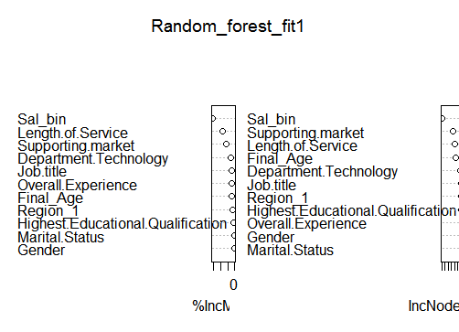
Random Forest Accuracy:
> confusionMatrix(Pred_rf, test1_nn$Resigned.y)
Confusion Matrix and Statistics

Reference
Prediction 0 1
0 2036 223
1 195 403

Accuracy : 0.8536927
95% CI : (0.8401967, 0.8664596)
No Information Rate : 0.780889
P-Value [Acc > NIR] : < 0.00000000000000022

Kappa : 0.565463
Mcnemar's Test P-Value : 0.1866304

Sensitivity : 0.9125952
Specificity : 0.6437700
Pos Pred Value : 0.9012838
Neg Pred Value : 0.6739130
Prevalence : 0.7808890
Detection Rate : 0.7126356
Detection Prevalence : 0.7906895
Balanced Accuracy : 0.7781826

'Positive' Class : 0

SVM

Parameter tuning of ‘svm’:

- sampling method: fixed training/validation set

- best parameters:
gamma cost
0.5 4

- best performance: 0.1165827878

- Detailed performance results:
gamma cost error dispersion
1 0.5 4 0.1165827878 NA
2 1.0 4 0.1235520382 NA
3 2.0 4 0.1320774640 NA
4 0.5 8 0.1216656544 NA
5 1.0 8 0.1309994588 NA
6 2.0 8 0.1360848890 NA
7 0.5 16 0.1295559201 NA
8 1.0 16 0.1379669351 NA
9 2.0 16 0.1436688413 NA
SVM Accuracy:

Confusion Matrix and Statistics

Reference
Prediction 0 1
0 5034 212
1 715 704

Accuracy : 0.8609152
95% CI : (0.8523749, 0.8691385)
No Information Rate : 0.8625656
P-Value [Acc > NIR] : 0.660085

Kappa : 0.5233838
Mcnemar's Test P-Value : < 0.0000000000000002

Sensitivity : 0.8756305
Specificity : 0.7685590
Pos Pred Value : 0.9595883
Neg Pred Value : 0.4961240
Prevalence : 0.8625656
Detection Rate : 0.7552888
Detection Prevalence : 0.7870968
Balanced Accuracy : 0.8220947

'Positive' Class : 0

control = list(minsplit = 20,
minbucket = 7, cp = 0, maxcompete = 4, maxsurrogate = 5,
usesurrogate = 2, surrogatestyle = 0, maxdepth = 30, xval = 0))
n= 6665

CP nsplit rel error
1 0.19735666 0 1.0000000
2 0.10648622 1 0.8026433
3 0.02551757 2 0.6961571

Variable importance
Sal_bin Length.of.Service Job.title Department.Technology
40 26 9 9
Final_Age Overall.Experience Supporting.market Region_1
7 5 2 1

Node number 1: 6665 observations, complexity param=0.1973567
mean=0.2087022, MSE=0.1651456
left son=2 (5263 obs) right son=3 (1402 obs)
Primary splits:
Sal_bin < 2.865551 to the left, improve=0.19735670, (0 missing)
Job.title < 0.6319673 to the left, improve=0.10401800, (0 missing)
Department.Technology < 0.8052911 to the right, improve=0.09990234, (0 missing)
Supporting.market < 0.4882226 to the right, improve=0.08718747, (0 missing)
Length.of.Service < 2.231977 to the right, improve=0.08041137, (0 missing)
Surrogate splits:
Job.title < 0.6319673 to the left, agree=0.837, adj=0.224, (0 split)
Department.Technology < 0.8052911 to the right, agree=0.830, adj=0.190, (0 split)
Overall.Experience < 2.469979 to the left, agree=0.818, adj=0.136, (0 split)
Final_Age < 7.897639 to the left, agree=0.817, adj=0.132, (0 split)
Length.of.Service < 2.814231 to the left, agree=0.814, adj=0.116, (0 split)

Node number 2: 5263 observations, complexity param=0.1064862
mean=0.1155235, MSE=0.1021778
left son=4 (3405 obs) right son=5 (1858 obs)
Primary splits:
Length.of.Service < 0.4852123 to the right, improve=0.21795690, (0 missing)
Overall.Experience < 1.999507 to the left, improve=0.05376810, (0 missing)
Final_Age < 5.891889 to the right, improve=0.02846568, (0 missing)
Supporting.market < 0.7501957 to the right, improve=0.02396520, (0 missing)
Department.Technology < 3.191339 to the left, improve=0.01720625, (0 missing)
Surrogate splits:
Supporting.market < 0.7501957 to the right, agree=0.681, adj=0.096, (0 split)
Final_Age < 5.641171 to the right, agree=0.677, adj=0.084, (0 split)
Department.Technology < 3.191339 to the left, agree=0.661, adj=0.040, (0 split)
Region_1 < 3.256888 to the left, agree=0.661, adj=0.040, (0 split)
Job.title < 3.821897 to the left, agree=0.650, adj=0.010, (0 split)

Node number 3: 1402 observations
mean=0.5584879, MSE=0.2465792

Node number 4: 3405 observations
mean=0.005286344, MSE=0.005258398

Node number 5: 1858 observations
mean=0.3175457, MSE=0.2167104

